Roadmap to Success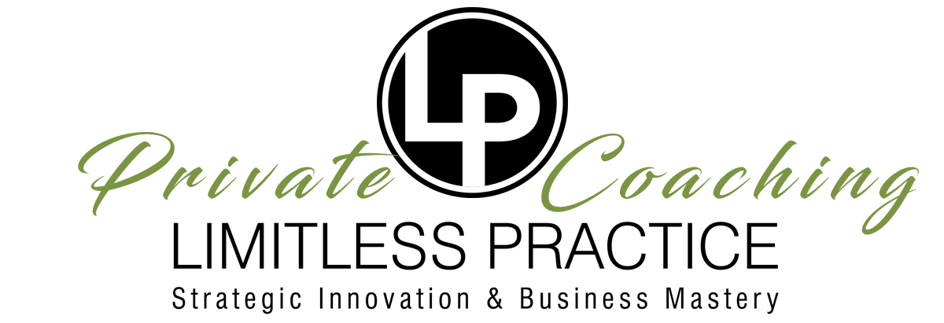

Current Status Of Key Areas

**PRODUCT & PROFITABILITY:**

What do your care(s) plan look like? (please be as detailed as possible)

What is your weekly patient visit average?

What is your cost per visit average?

What is your income breakdown for the practice? (cash, insurance, ancillary services)

What is your gross annual revenue?

What is your net profit?

What is your operating cash position?

What does your average appointment look like?

What is your average encounter time? (face to face with doctor)

What is your average appointment time? (total time in office)

What is the average value (AV) of a new patient initial care plan?

What is the average annual value (AV) of a wellness client?

What is your average NP signup percentage?

What is your average resign percentage?

**PEOPLE & PROCESSES:**

Explain each key employee in detail, names included.

* What are their strengths?
* What are their weaknesses?
* What improvements do they need to make?
* What can you do to help them?

What most excites you about the Team culture in your business?

How often are you holding team meetings?

What can you do to improve your Team’s culture?

What is your USP (unique selling proposition), competitive advantage, what makes you different?

What is your marketing strategy? (Core 4X4)

Who is your customer? Describe primary, ideal client & secondary demographic

Do you track office stats?

What stats do you track and how often?

What stats do you need to get better at tracking?

What impresses you about your sales process?

What strategies have you deployed to improve your sales process?

What part of your sales process needs improvement?

Defining The Ideal Outcome & Game Plan For Success

What is our ideal outcome, *i.e. “how do we define winning”?*

What is the ultimate goal of the practice? Options might include: number of visits, revenue, clinical and/or non clinical patient outcomes, patient education, relationship building, other practice or business achievement parameters, etc.

What is our strategy for success, *i.e. “what’s the game plan”?*

Instead of just winging it, what is the ideal game plan for consistently achieving our ideal outcome? How will we win more often? Options might include: financial planning, mapping office procedures, measuring and reporting stats, relationship and/or performance building programs for patients, team, community, etc.

Using only one word, what is your role in this process, *i.e. “what’s your position”?*

Narrowing your focus, or identity down to only one word can be very empowering… especially when every member on the Team agrees with the rationale for its choice.

What key elements will success hinge upon, i.e. “how do we score”?

*What are the key elements of the strategic game plan must we always be focused on and executing properly in order to guarantee success? Options might include: adherence to care plan, attendance or participation in patient education programs, seminars, referrals, reviews, etc.)*

How do we measure quality of the outcome, *i.e. “how do we keep score”?*

What stats can we track to grade our efforts by? Options might include: signup, resign, referrals, reviews and testimonials, family care plans, attendance to events, revenue, service delivery performance timing, etc.

What obstacles must we anticipate, *i.e. “what is our competition”?*

What obstacles can we anticipate? Options might include: lack of new patients, retention problems, lack of revenue, poor stats in other key areas, time and resource management issues, inconsistent planning, training issues, staff performance issues, lack of essential resources, limiting beliefs, etc.

How can we minimize obstacles, *i.e. “how do we overcome the competition”?*

What actions must we take to avoid or minimize obstacles? Options might include: cash reserves, cross training, automation, planning calendars, team trainings, more meetings, standards assessment, improved clarity of vision, innovating service delivery process, etc.

*Growth and Development (Company Focused):*

**In the next 3-6 months, what Outcomes would we like to make measurable progress on and why? *(Outcomes, i.e. operational advancements to or within the Company)***

**What Outcomes would we like to see other Company members make progress on and why?**

**How can we help those members better achieve these Outcomes?**

**What is the one thing, that if we had it accomplished today, would make the biggest difference in closing the gap between where we are now and where we want to be at the end of the year?**

**If the only hurdle between where the Company is now and where we would like to be is the support of others:**

* **Whose support do we need?**
* **What specific support is needed?**

Company Organization:

**What specific changes in Company organization need to take place in order for the Company to progress as I hope it to?**

**How can I play a role in making these changes?**

Task Organization and Time Management:

**What challenges regarding organization and task management am I currently facing?**

**What specific changes can I make to improve my level of organization and task management?**

Management Style:

**What changes have I made in my management style within the last couple months?**

**What challenges regarding effective management am I currently facing?**

**What changes will I make in my management style in the next 3-6 months?**

Company Goals and Vision:

**What are the goals for our business in the next period and/or the remainder of the year?**

**What are the steps our business needs to take to achieve these goals?**

**What would be an outrageous, yet feasible goal our business could accomplish this year given the correct resources were at our disposal?**

**How can we obtain and leverage these resources?**

Personal Goals:

**What personal goals do I have that hinge on Company growth and success? (i.e. time, travel, money, career, etc.)**